MAT 315: Applied Probability and Statistics Lab 2: Introduction To R and RStudio
Topic: Food Security Survey

In this Lab we will cover:
- Creating a data frame
- Importing a data frame
- Missing values
- Normal quantile plot (Normal probability plots)
- Review from Jupyter Notebook: Labeling variable outcomes, creating a table, pie chart, bar chart, histogram, boxplot, numeric summaries (mean, standard deviation, five-number summary)
Since this is a Word document, you can insert your answers directly into this document (and when finished submit via assignments). Answer all questions and insert requested R output shown in red.

About the data:
The dataset for this lab contains data on 13 variables extracted from a 2017 Food Security survey conducted by the United States Census Bureau. The variable names are: PESEX, PRTAGE, PEMLR, GEREG, PRHRUSL, PRNMCHLD, HEFAMINC, HETS8OU, HESSM3, HESSM4, HESCM, HESC4, HRPOOR. (The complete dataset contains over 100 variables.) You’ll need to open the file Food_codebook2017 in order to find out what these variables are. We’ll look at a few of these variables in this lab and time permitting, others later in the semester. In fact, food insecurity, which affects children, college students, and elders, is a really important issue in the United States and has worsened during the COVID pandemic.

Getting Acclimated to RStudio

1. a. Open RStudio. You should see 3 panels as shown below. (If you have previously opened a script, you may see an additional panel.) The console, left (or lower left) is where commands run. The Workspace contains the Environment (shows all the dataframes and variables you have created) the History (shows the commands you have already run), and a tutorial tab (see last paragraph of Instructions for Downloading R and RStudio).

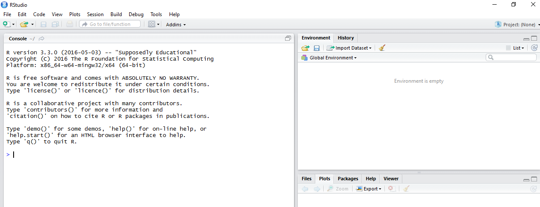
b. Type demo( and notice that the right parenthesis is automatically entered once the left parenthesis has been typed. Press the Enter key. This will open up another window directly above the Console. For now, click the x on the R demos tab (toolbar near top) to close this panel.

c. Type the following command, and hit Enter:
>ls( )

You should see: character (0) if you have nothing in your workspace. Otherwise, you will see whatever files are saved in your workspace.

d. Type the following commands into the R command panel (Console). Note that R is case sensitive. So, the letters in each command should be lowercase. Look to the right to see the output.
- help( )
- help.start( ) [Notice that this gives you access to several R manuals.]
- demo(graphics) [Press the Enter-key several times to view the demo. Look both in the Console panel and in the Plots tab in the lower right panel. Hit Esc to exit out of the demo.]
e. Click q( ) and then press the Enter key to quit. (You can also quit with File>Quit Session.) Don’t save your workshpac.

Preparation for this Lab

- You already should have created a MAT 315 folder in your OneDrive. If you have not already done so, inside your MAT 315 folder create a Lab subfolder, and inside that a Lab 2 subfolder. Go to Blackboard and copy the files FoodSurvey.csv and Food_codebook2017 into the Lab2 folder.
- Open RStudio.

- Set the working directory to the Lab 2 folder that you just created. To do that, click the Session tab select Set Working Directory>Choose Directory as shown below.
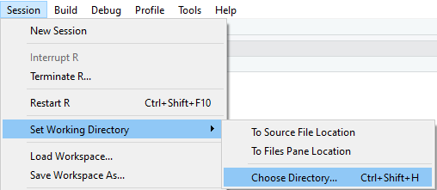
A browser will open. Use it to find the Lab 2 folder. Click Lab 2 and then Open
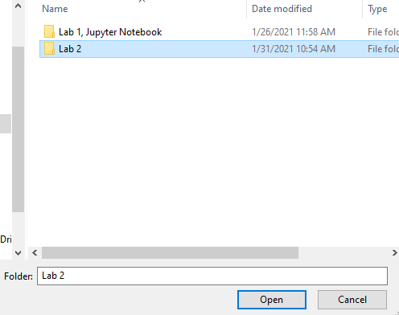

- Next, you will open a new panel for scripts: click File>NewFile>RScript. You will now see a new panel above the Console panel.This panel is a source editor where you can type in commands, highlight a group of commands and then run them (similar to a Code cell in Jupyter Notebooks).
- To give the script a name: File>Save As> name the script Lab 2, you should end up in your working directory click Save. (Note the tab at the top of the scrips panel changes from Untitled to Lab2.) In your Lab2 folder, you should now see something like this:
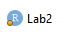

Data Frames

In Jupyter Notebook, you created data vectors. A data vector contains data values which are all of the same type - quantitative, categorical, or logical (TRUE, FALSE). In Lab 2, we introduce the data frame. A data frame consists of rows and columns, similar to a matrix. The rows correspond to cases (individuals) and the columns to variables, which can include the variable names as column headers. The data values within a column must be of the same type. But the different columns can contain different types of data. For example, one column could contain quantitative data on age and another categorical data on gender. All columns in a data frame must have the same length because they were collected on the same individuals.

Creating a Data Frame

One way to create a data frame is to enter the data vectors on each variable and then combine them into a single data frame. The table below contains data on the first six individuals in a 2017 Food Security survey conducted by the United States Census Bureau. Your first task will be to take the data in the table below and create a data frame in R. Instructions follow the table.
Sex | Age | EmpStatus | SpendFood
Female | 53 | Employed | 4
Male | 64 | Retired | 500
Female | 59 | Employed | 500
Male | 61 | Employed | 100
Female | 26 | Employed
Female | 44 | Employed | 120

In the scripts panel:

1. a. Write the code for creating a data vector with the sex of the first six individuals in the survey and call this vector Sex:
Sex <- c("Female", "Male", "Female", "Male", "Female", "Female")
(Note: In RStudio, a shortcut for entering <- is to simultaneously press Alt –.)

b. Next, write the code for creating a data vector for Age. (Note: Do not use quotes around numeric data values.)

c. Next, write the code for creating a data vector for EmpStatus. Follow the pattern from (a).

d. Finally, type in the code to create the data vector for SpendFood. (There is a missing value in this data set. To indicate that the fifth individual surveyed did not answer this question, write NA for not available. Do not use quotes around NA. )

e. Now it’s time to run the code that you created in (a – d) just as you would in a Jupyter Notebook code cell. To run the code you have entered into the scrips panel for (a – d), click on the top left of the first line of code and drag to highlight all the commands you have written thus far. Then click Run (at top of scripts panel) or use the shortcut of simultaneously pressing Ctrl Enter. All of the commands that you have highlighted will be executed. (Check this out by looking in the Console panel.)

2. a. Check out your Global Environment (See Environment tab in upper right panel). You should see the individual variables (data vectors) you have created. Next, you will combine the data vectors from question 1 into a single data frame named Food and then print Food. The command for creating the data frame is data.frame (all lowercase letters). Here’s the code which you should enter in your scrips panel:
Food <- data.frame(Sex, Age, EmpStatus, SpendFood)
Note: No quotes are used here. These are variable names and not string data. For variable names, you cannot have any spaces. That’s why I didn’t use any spaces for Employment Status but shortened the name to EmpStatus. If you want a space, use an underscore or period. For example, Emp.Status or Emp_Status would also be legal variable names.
Food (This command prints the contents of the data you stored in the command above.)
Highlight these two commands and click Run (or Ctrl Enter).
The output will appear in the Console panel.

Sex Age EmpStatus SpendFood
1 Female 53 Employed 4
2 Male 64 Retired 500
3 Female 59 Employed 500
4 Male 61 Employed 100
5 Female 26 Employed NA
6 Female 44 Employed 120

b. Check your Global Environment panel (top left panel). You should see the data frame Food. Click the arrow to the left of Food.

I see that I have my Variables $ sex age empstatus and spend food there, then it describes that there are 6 jobs of 4 variables and it tells me what each variable has.

c. Next, click on Food in the Global Environment panel. A table of the data will appear in your scripts panel. To close this table, click the x on the tab marked Food.

3. a. Next, we want to check out the structure of the data frame. Type in the command below. To run this single command, you won’t need to first highlight it. Instead, with your cursor placed anywhere on the command line, just click Run or press simultaneously Ctrl and Enter.
str(Food)

(The output of this command should be a repeat of what you saw for 2(b) in the Global Environment panel.) Notice that the structure for Age and SpendFood is numeric (num); Sex and EmpStatus are listed as factors with two levels, Male, Female and Employed, Retired, respectively.

b. Make a bar chart of Sex but first, here are some important things to note:
- Since other data frames also could have variables named Sex, you will need to identify which data frame’s variable Sex you want to use (R can’t figure this out on its own!). So, here’s how you must refer to a specific variable within the data frame named Food:
Food$Sex

- Recall from your Jupyter Notebook assignment that the input for barplot and pie commands is a table. So, you’ll have to create a table before you can make a barplot or pie chart.
- Here’s a reminder of how to do that. First, we’ll create the table and name it Table_Sex, next we’ll print the table to make sure it is what we want, then we’ll make the bar chart and pie chart:

Table_Sex <- table(Food$Sex)

Table_Sex (This command will print the table so you can view it.)

barplot(Table_Sex)

pie(Table_Sex)

Copy your plots into your lab. Here’s how:
- After creating the barplot, click Export and select Copy to Clipboard.
- Click Copy Plot.
- Then put the cursor where you want it in your lab write-up and click simultaneously Ctrl V to paste the plot into your lab.
- Repeat this process for your pie chart.

Shortcut: Return to the commands:

Table_Sex <- table(Food$Sex)

Table_Sex (This command will print the table so you can view it.)

Test this out: As an alternative to using two commands, one to create and store the table and the other to print the table, just put parentheses around the table command:

(Table_Sex <- table(Food$Sex))

c. Use the shortcut above to make a table of EmpStatus.

> (Table_EmpStatus <- table(Food$EmpStatus))

Employed Retired

5 1

Copy the results from (c).

Importing Data
Usually when dealing with data frames, you will be importing data from an outside file. You should already have saved the file FoodSurvey.csv in the folder MAT315>Labs>Lab2 on your OneDrive (or if you are having trouble with your OneDrive, saved onto a flashdrive). Next, you will read the file into RStudio.

4. a. Import FoodSurvey.csv. There are several different ways to do this. Here’s one way:

FoodSurvey <- read.csv(file.choose())
Note: As you begin typing this command, R will give you options to complete it. You
might see something like this:

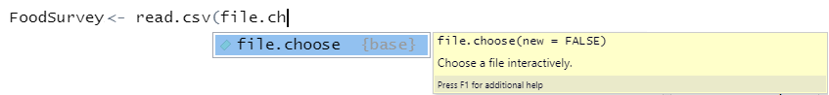
At this point you can just press Enter and R will autocomplete the command.
Press Ctrl Enter (or click Run).
This should bring up your browser – but it may be behind your RStudio panels, in which case you might not see it. If that is the case, minimize RStudio. Find the file FoodSurvey and click on it, then click Open.

Here’s a second way to import the data, which you might like better.
- Under the Environment tab, click Import dataset and select From text(base).
- Your browser will come up. Find the dataset you want to import and select it.
- An Import dataset box will pop up. The only thing that you need to change is Heading from No to Yes. (This is important!) Then you should see your data with headings (variable names) at the top of each column. Click Import.

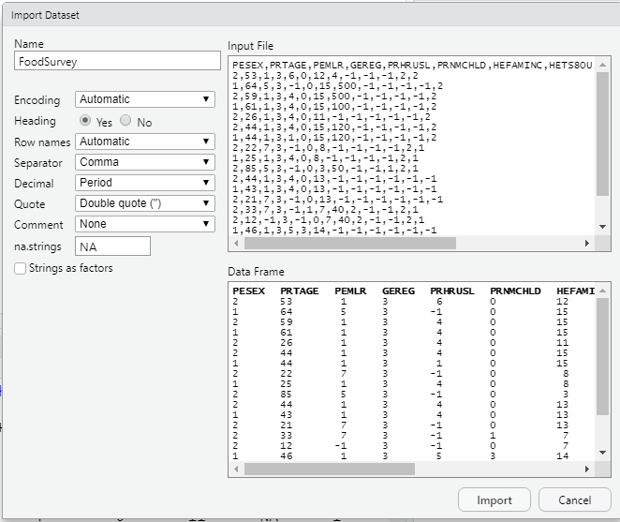

b. Look at FoodSurvey in your Global Environment panel. How many individuals participated in this survey? How many variables are there?

126065 participated

13 Variables

c. Because there are so many cases in the FoodSurvey dataset, we do not want to print out the entire dataset. Instead, we’ll just print out the first six cases using the head command. Here’s how:

head(FoodSurvey)

Copy the output and insert into your lab.

PESEX PRTAGE PEMLR GEREG PRHRUSL PRNMCHLD
1 2 53 1 3 6 0
2 1 64 5 3 -1 0
3 2 59 1 3 4 0
4 1 61 1 3 4 0
5 2 26 1 3 4 0
6 2 44 1 3 4 0
HEFAMINC HETS8OU HESSM3 HESSM4 HESCM3 HESC4
1 12 4 -1 -1 -1 2
2 15 500 -1 -1 -1 -1
3 15 500 -1 -1 -1 -1
4 15 100 -1 -1 -1 -1
5 11 -1 -1 -1 -1 -1
6 15 120 -1 -1 -1 -1
HRPOOR
1 2
2 2
3 2
4 2
5 2
6 2

Working With the FoodSurvey Data Frame

To understand what the variable names refer to and what the column values mean, you need to look at the FoodSurvey_codebook2017.

5. a. Before you can make much sense out of the values for PESEX, you’ll need to code the 1s to Male and the 2s to Female as indicated in the codebook. (Recall: You did this in your Jupyter Notebook.) Here’s the command in case you have forgotten:

FoodSurvey$PESEX <- factor(FoodSurvey$PESEX, levels = c(1,2), labels = c(“Male”, “Female”))

Take another look at the structure of the command above. You will be using it throughout this semester.

b. Now, check out what has happened to this variable in the Global Environment panel: Click on FoodSurvey. How did the command in (a) change the entries in the column PESEX?

It changed the 2’s into female and the 1’s in Males.

6. a. The variable PRTAGE is numeric in value. Make a histogram of the respondents’ ages. Add an x label (Respondent’s Age), a nice color (such as light blue – or check out other color choices in the file RColor posted in Blackboard).

In case you have forgotten, here’s the code:

hist(FoodSurvey$PRTAGE, xlab = “Respondent’s Age”, col = “lightblue”)

Do you like the title that is automatically generated by R? Add your own title by inserting a comma after the command for creating color and then adding the command:
main = “insert your title”

Insert a copy of your histogram with your chosen title.

b. Describe the shape of the age data. What does this tell you about the ages of the individuals surveyed?
I would say that this histogram looks roughly uniform but then towards the end it starts to skew to the right. This tells me that during the survey, the people conducting this survey were having a difficult time finding older people to survey.

c. Make a boxplot (horizontal orientation, need to add horizontal = TRUE in the boxplot command) of the age data. Again, label the x axis, add a nice color (different from the one you used for age), and give the display a title.

‘
Insert a copy of your boxplot.
Insert your answers to (d – g)
d. Based on your boxplot, would you describe the shape of the data as symmetric or skewed? How can you tell? Are any outliers apparent?

Looking at the distribution, It looks to be symmetric because the median, Q1, & Q3 All seem to be an equal distance apart from each other. The IQR is closer to the minimum so it could be skewed to the right a bit.

e. A normal distribution is bell-shaped. Data from a normal distribution is mound-shaped and roughly symmetric. Based on your histogram and boxplot, do you think these data come from a normal distribution? Explain.

I don’t think this would look like a normal distribution since most of the data provided is roughly symmetric. There is no bell shape since it looks symmetric.

f. Make a normal quantile plot of the age data. Add a line to the plot. (Insert the plot.) Based on your plot, is it reasonable to assume that survey participants’ ages are normally distributed? Explain.
qqnorm(FoodSurvey$PRTAGE)
qqline(FoodSurvey$PRTAGE)

g. What is the mean age of the survey respondents? Compare that to the median age.

The mean age is about 30ish. The qq line shows that the median and the mean are pretty close together.

7. Next, we look at the usual amount that respondents spent on food per week: HETS8OU. Notice that the codebook gives three categories of missing values -9 (No response), -3 (Refused) and -2 (Don’t know).

- Use the summary command on HETS8OU. Insert the outcome below.

> summary(FoodSurvey$HETS8OU)
Min. 1st Qu. Median Mean 3rd Qu. Max.
-1.0 -1.0 80.0 103.4 160.0 500.0

b. In the actual data, the three sources of missing values designated in the codebook as -9, -3, and -2 have all been coded as -1. We need to recode these values as NA in order to analyze the usual amount that respondents spent on food per week. Here is one way to do this in R (and this command would work if the values had been recorded as -9, -3, and -2 instead of -1):
FoodSurvey$HETS8OU[FoodSurvey$HETS8OU < 0]=NA

Go back to the line with your summary command. Rerun the command. What is the minimum data value now? 0

c. Make a histogram of the data in HETS8OU. Label the x-axis, color the bars, and add a title to the display. Describe the shape. (Insert the histogram into your lab.)

The shape of the histogram is skewed right

d. Make a boxplot of the usual amount spent on food weekly (insert into your lab). Are there any outliers?

Yes, there is a bunch of outliers.

e. Use the summary command to create a five-number summary. (Insert the output.) How many of the values are missing values? Based on your graphic displays, would the mean or median be a better measure of center for the usual weekly amount spent on food?

The median would better because because this data has a lot of outlier and it is extremely skewed

> summary(FoodSurvey$HETS8OU)
Min. 1st Qu. Median Mean 3rd Qu. Max.
0.0 80.0 130.0 153.5 200.0 500.0
NA's
40870

f. Is it reasonable to assume that these data are from a normal distribution? Make a normal quantile plot to support your answer. (Insert your plot)

It wouldn’t say its a normal distribution because the points dont
Show a linear line.

8. Let’s look at a variable that gets at the issue of food insecurity: HESSM3 (in the past 30 days, food bought didn’t last).

a. Just as you did for the variable PESEX, refer to the codebook and label the data as Yes or No (ignoring other values will make them missing values). To check you have done this correctly, run head(FoodSurvey$HESSM3) to see the first 6 data values. Insert the output in your lab.
> head(Food_Survey$HESSM3)
[1] -1 -1 -1 -1 -1 -1

b. For the respondents who answered this question, what percentage replied yes and what percentage replied no? Here’s a reminder of how to make this table:
Table_notlast <- table(FoodSurvey$HESSM3)
Table_notlast_percent <-prop.table(Table_notlast)*100
Table_notlast_percent

Yes: 50.84%
No: 49.16%

Reminder: If you enclose the middle command above in parentheses, you won’t need the last command.

Make a graphic display to represent the table. Make either a barchart or a pie chart. (Use commands barplot or pie. Remember the input to these commands must be a table.)
Insert in your lab.

We will be formally covering two-way tables starting next week. So, do the best that you can on parts (c) and (d).

c. We're males or females more likely to respond Yes to this question? For this you will need a two-way table. If Sex is the row variable, then you will need row percentages. Here’s a reminder of how to make this table:
Table_Sex_notlast <- table(FoodSurvey$PESEX, FoodSurvey$HESSM3)
(Table_Sex_notlast_RowP <- prop.table(Table_Sex_notlast,1)*100)
Note: The 1 in the command above will create row percentages. Because I surrounded the command with parentheses, it will print the tables.
Make a barplot to represent the table and insert in your lab. Add labels to your bar-plot and choose colors.

d. From which region of the country, Northeast, Midwest, South, West, were respondents more likely to respond Yes to this question? (For this you will need to label a new variable, create a two-way table, and then decide if you want row or column percents. (For column percents, you would need to change the 1 to a 2 in the command from (c).)

Make a graphic display to represent the table and insert in your lab. Add labels to your barplot and choose colors.

